Summarizing the Student’s Placement Data

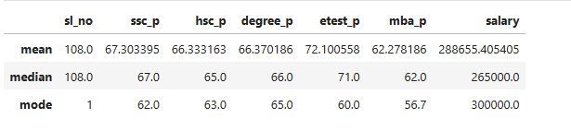

In the last year,

1. students performed above average in SSLC, HSC, Degree, and MBA.
2. However, their average marks in entrance test results were moderate.
3. Based on our placement records, the average salary package received by students was 265,000. I have taken the median since outlier present in the salary based on the mean and median difference.
4. Most students' SSLC marks were 62.
5. Most students' HSC marks were 63.
6. Most students' Degree marks were 65.
7. Most students' Entrance test marks were 60.
8. Most students' MBA marks were 56.7.
9. Most students received a salary of 300,000.